**Lunae Latius’s Design Document**

**Introduction**

Game Summary 2

Inspiration 2

Player Experience 2

Platform 2

Development Software 3

Genre 3

Target Audience 3

**Concept**

Gameplay Overview

Theme Interpretation (It’s Spreading)

Primary Mechanics

Secondary Mechanics

**Art**

Theme Interpretation

Design

**Audio**

Music

Sound Effects

**Game Experience**

Ui

Controls

**Development Timeline**

**Introduction**

**Game Summary:**

Lunae Latius is a side-scrolling endless runner game where you must try your best to outrun death itself for as long as you can.

**Inspiration**:

Jetpack Joyride

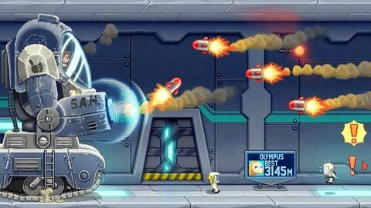Jetpack Joyride is the main inspiration

for the genre and is the main factor

behind many decision making when it

came to designing our game, namely

the core concept of *endless running*

*while dodging projectiles*

**Player Experience:**

The player will have to *continuously evade every attack* aim at them while /////

**Platform:**

The game is developed for Windows PC

**Development Software:**

* Godot 3.5 for programming
* Aseprite for graphics and UI
* Anvil Studio for all music
* Pixapay for any SFX

**Genre:**

Singleplayer; Side-scrolling; Endless runner

**Target Audience:**

Using simple control and mechanic, this game is marketed toward casual game players who are looking for a way to pass time.

**Concept**

**Gameplay overview**

The player’s controlled unit will always move forward, you as the player will have to decide when to jump to get collectible and dodge any hostile attacks.

**Theme Interpretation (It’s Spreading)**

-The boss’s name is Spreading, literally.

-Spreading will continue to get bigger and bigger by absorbing all the collectibles that you missed. ***Everything you do only serve as a temporal way to lengthen your own life, you can not stop The Spreading, it will consume you and it will consume us all***

**Primary Mechanics**

-Spreading: The boss will continuously chase and attack you, the speed won’t change but the interval between its attack will be greatly reduced per level.

-Collectibles: The player can pick up gems to increase their point while reducing the boss’s growth speed

-Fire extinguish: The player’s main method to travel upward

**ART**

**Theme Interpretation**

**-**There will be no specific color palette theme in this

project.

**Design**

Visual assets and sprites will be fully done with pixel art

style while aiming to be as close to the reference pictures

as possible.

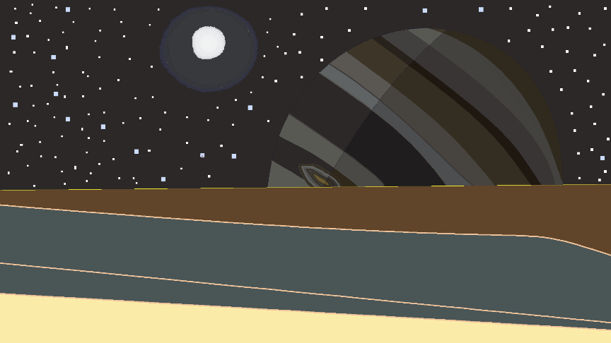

**AUDIO**

**Music**

To compliment with the pixel art style, 8-bit based music

will be used to deliver the main and only soundtrack of the game.

**Sound Effects**

To give a better experience for the players, the sound

effects are given much more care and aim to stimulate real

sound.

**GAME EXPERIENCE**

**UI**

**Controls**

**Keyboard**

Arrow keys/WASD

**DEVELOPMENT TIMELINE**

**Minimum viable product**

|  |  |  |  |  |  |
| --- | --- | --- | --- | --- | --- |
| **ID** | **ASSIGNMENT** | **TYPE** | **STATUS** | **FINISH BY** | **NOTES** |
| **1** | **Design document** | Other | Finished | **Jan 19,2024** |  |
| **2** | **Player and wall**  **Asset** | Other | **Finished** | **Jan 19,2024** |  |
| **3** | **Boss assets** | Other | **Ongoing** |  |  |
| **4** | **Simple Mechanic** | Coding |  |  |  |
| **5** | **Collectibles assets** | Other | **Ongoing** |  |  |
| **6** | **Player’s animation** | Other | **Ongoing** |  |  |
| **7** | **Boss’s animation** | Other | **Ongoing** |  |  |
| **8** | **Sound Effects** | Audio | **Ongoing** |  |  |
| **9** | **Pause Menu** | Coding | **Ongoing** |  |  |